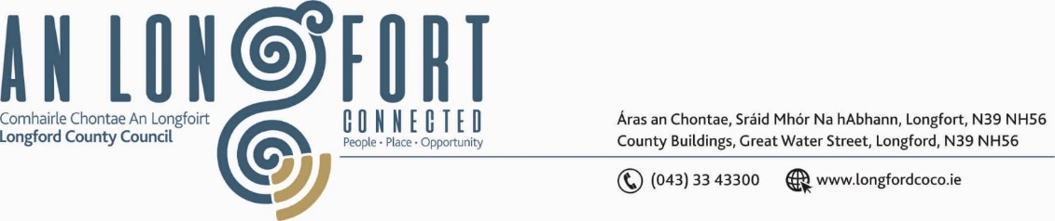

**GRANARD MUNICIPAL DISTRICT**

***Please note meeting will be held in Granard Library.***

**22nd September 2021.**

**To: Each Member of Granard Municipal District.**

**Dear Member,**

You are requested to attend the Meeting of Granard Municipal District to be held

**Granard Library** on **Tuesday, 28th September 2021 at 3.30pm** to transact business, as set out on the Agenda hereunder.

**Yours sincerely**,

Ann Marie Mc Keon

______________________

**Ann Marie Mc Keon,**

**Meetings Administrator.**

**AGENDA**

Prayer before meeting.

**1.** Confirmation of Minutes as follows: -

* Granard Municipal District Committee Meeting held on 27th July 2021 – copy enclosed.
* Granard Municipal District Meeting held on the 27th July 2021 – copy enclosed.

**2.** Matters arising from Minutes.

**3.** Declaration of Interest by Members.

**4**. Consideration of the Granard Regeneration Strategy - Presentation

**5.** Management Report incorporating Area Engineer’s Progress Report

- enclosed.

**6.** Granard Public Art Features.

**7.** Proposed Projects/Expression of interest – enclosed.

**8.** Consideration of applications for funding under the 2021 Community Grant Support

Scheme – list enclosed.

**9.** Special Projects Funding / Discretionary Grants 2021 - list enclosed.

**10.** Notices of Motions, submitted by Councillors, as listed hereunder –

**Councillor PJ Reilly**

I wish to put a motion forward to the meeting for the Council to carryout essential repair works on the footpath on the R194 Granard to Ballyjamesduff road on the outskirts of Granard town. This footpath is in very bad repair and is a danger for all the pedestrian that use the path walking in and off town.

**Councillor Colin Dalton**

I call on Longford county council to commence a programme of Refreshing Road Markings along Roads and Junctions within the Granard Municipal District.

**Turlough Mc Govern**

(i) "I call on Longford County Council to put speed ramps in place in the Teemore Industrial Estate due to the excessive speed of some vehicles exiting on to the main N55.

(ii) “I call on Longford County Council to carry out a speed survey on the main N55 in Granard Town (from the Edgesworthtown side at entrance of Rathcronan Estate to Knights and Conquest building) due to excessive speeding.

**11. Correspondence**

Correspondence dated 25th August 2021 - Received from Irish Water Re – Sewerage in Drumlish – enclosed.